TECHNICAL PROJECT REPORT

# Title of Invention / Project:

BLUETOOTH DOOR LOCKER

# Team Members / Inventors:

|  |  |  |  |  |  |
| --- | --- | --- | --- | --- | --- |
| **S.No.** | **Name** | **Department** | **Designation** | **Mobile** | **E-Mail** |
| 1. | JAYANT KERNI | ECE | STUDENT | 9682685977 | jayantkerni@gmail.com |
| 2. | ABHISHEK VERMA | ECE | STUDENT | 7800039987 | abhishek456v@gmail.com |
| 3. | VIKRAM KUMAR | ECE | STUDENT | 8094656264 | vikram.kumar@bk.ru |
| 4. |  |  |  |  |  |
| 5. | Khushal Thakur | ECE | Mentor | 9646030764 | khushal.thakur@cumail.in |
| 6. | Anshul Sharma | ECE | Mentor | 9478697475 | anshulsharma.ece@cumail.in |
| 7. | Kiran Jot Singh | ECE | Mentor | 9463909689 | kiranjotsingh.ece@cumal.in |
| 8. | Divneet Singh Kapoor | ECE | Mentor | 9878422653 | divneet.ece@cumail.in |

Section – 1 (IPR Related)

# Abstract

* Security is becoming an important issue everywhere nowadays. Every person wants his house, factory; bank etc to be secured. House security is necessary as the possibilities of intrusion are increasing day by day.

In this paper, door security system has been designed that has a unique feature. Arduino was used, which is considered one of the modern programmable device and we also used HC-05 wire less Bluetooth transreceiver so as to control door here, our application uses Arduino as its controller and HC-05 as a communication link between mobile application LED.

# Existing state-of-the-art and Drawbacks in existing state-of-the-art

|  |  |  |
| --- | --- | --- |
| **S. No.** | **Existing state of art** | **Drawbacks in existing state of art** |
| 1 | In existing state of art a Bluetooth and arduino is used in the lock. | There is no siren or sound like thing from which we can able to know that the door is locked or not-locked. |
|  |  |  |

# Novel/Additional modifications that you can propose to improve upon drawbacks

* We can add sound buzzer in bluetooth door locker from which we can able to know weather door look is lock or not.
* We can also make our project water proof by covering the delicate items like bluetooth, motor.

# Advantages

* In our project almost all main parts are covered in the box like arduino, breadboard, wiring.
* it is controlled by a pin lock and using three numbers we can turn on , off, or stop the lock(0,1,2)

# Block Diagram

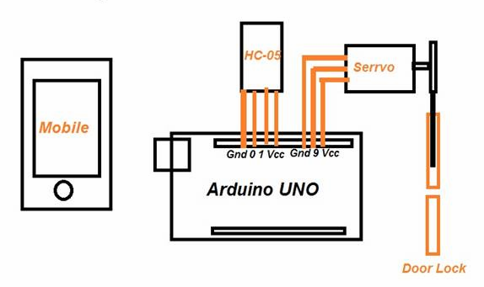

Section – 2 (Real Project)

# Materials

We have used various types of things

1. Arduino Uno
2. Bluetooth (HC-05)
3. breadboard
4. Wires
5. Do motor
6. Door lock
7. Empty box
8. Injection Cap
9. Motor driver
10. Battery

# Circuit Diagram

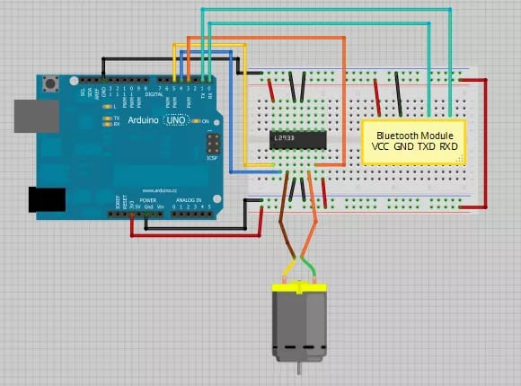

# Steps of Circuit Completion

1. First we take the required material which we need.
2. Assemble the required things.
3. Then we make the connections as given above in circuit diagram.
4. then we pack the above connection in the box.

# Program Code

https://github.com/BTdoorlocker/Bt.git